Screenshots of Cyber Risk and Threat Intelligence Platform
- Noor Nabeeha K

Before Scanning (Naive User):
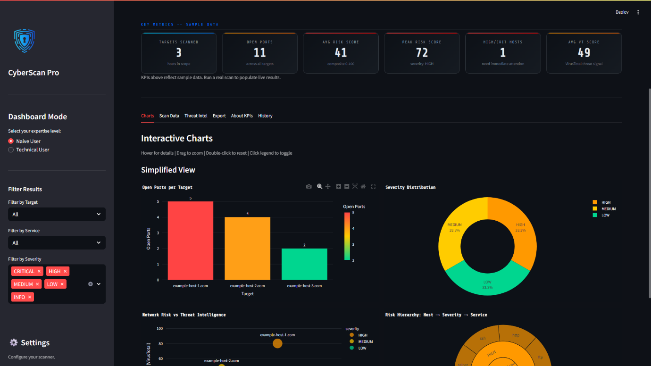
Dashboard containing KPIs and interactive charts - 1
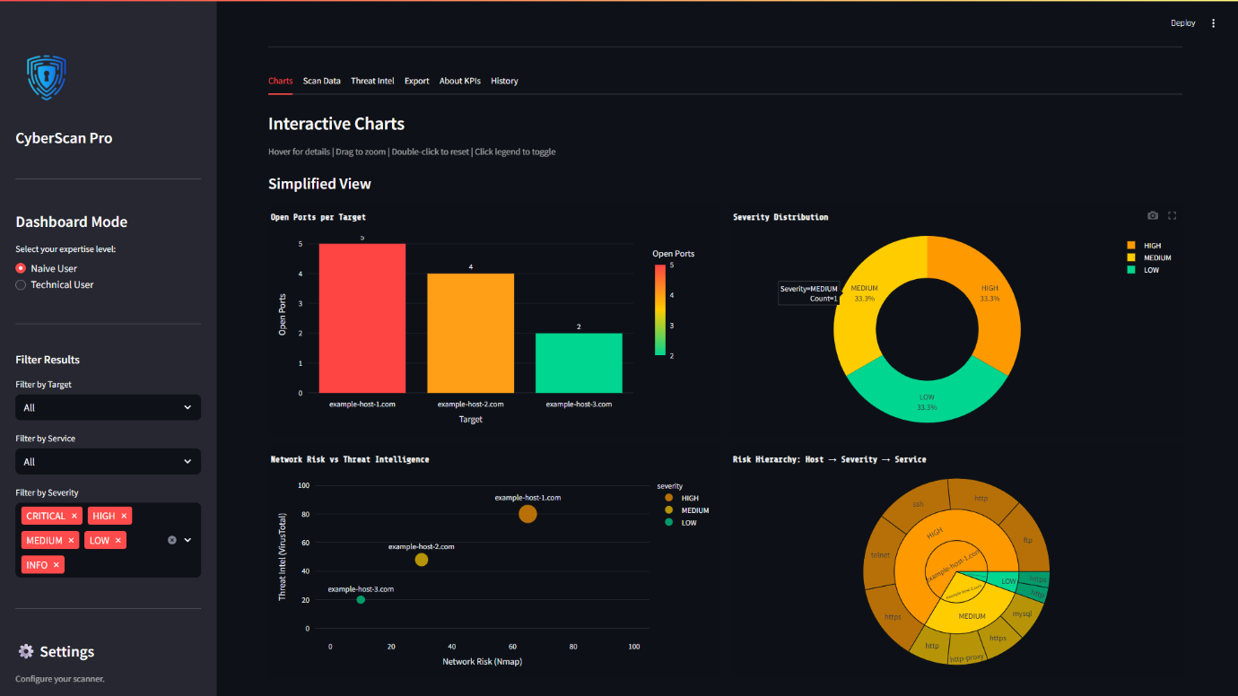Dashboard containing KPIs and interactive charts - 2
Before Scanning (Technical User):
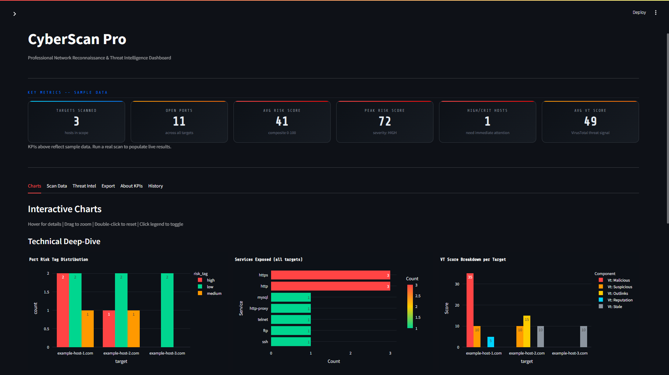
Dashboard containing KPIs and interactive charts – 3

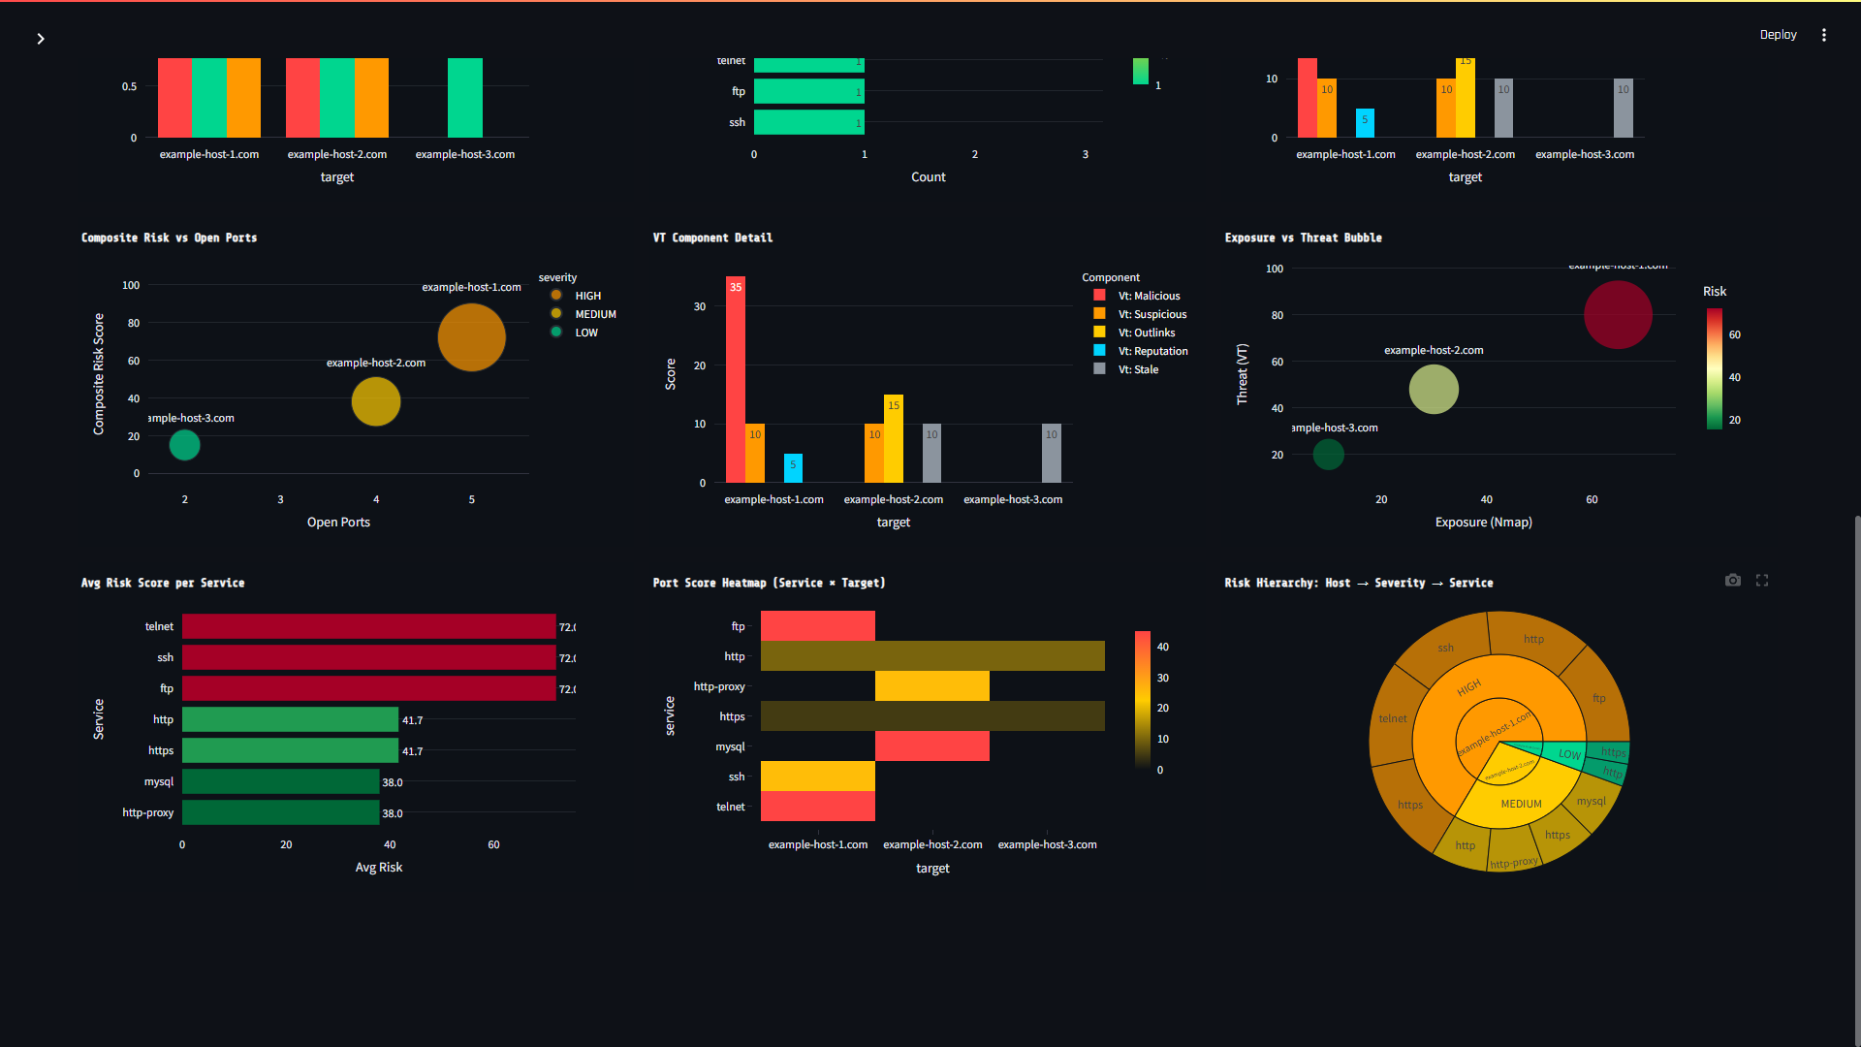
Dashboard containing KPIs and interactive charts – 4

During Scan:
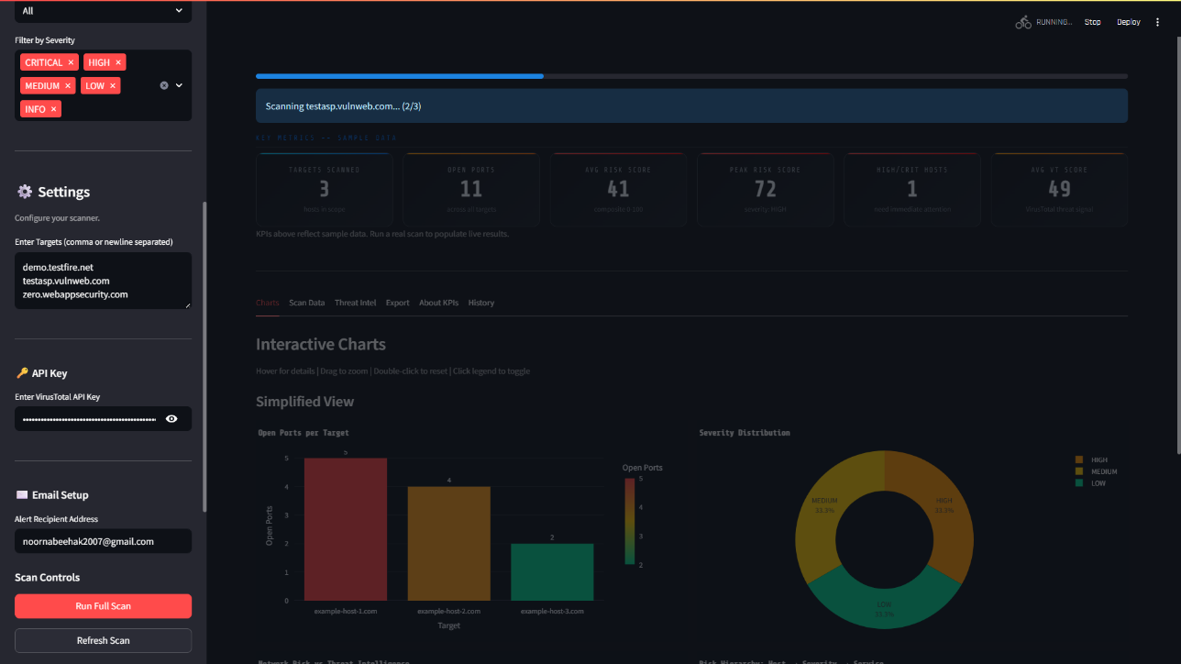
Scanning testasp.vulnweb.com (2/3)
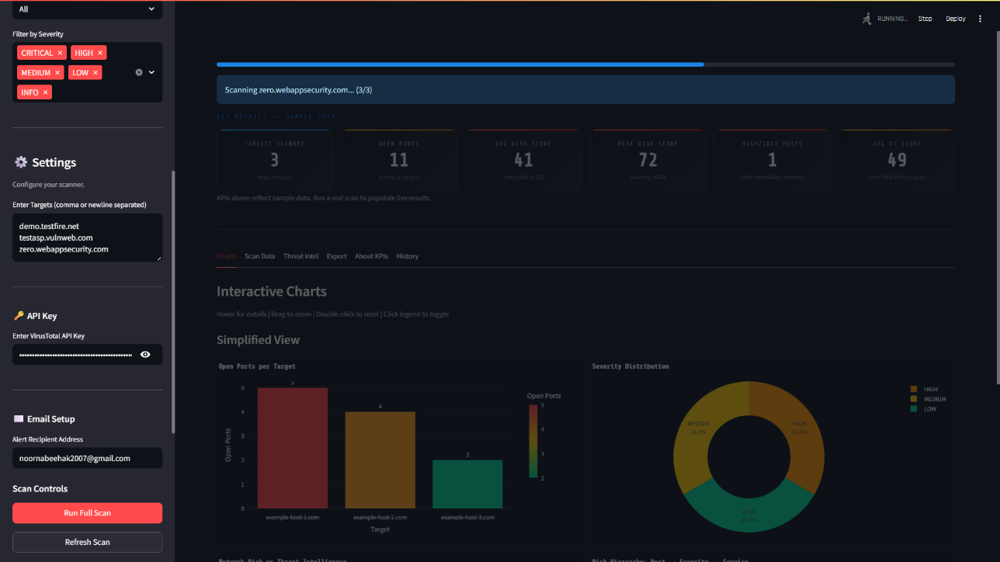
Scanning zero.webappsecurity.com (3/3)

After Scan:
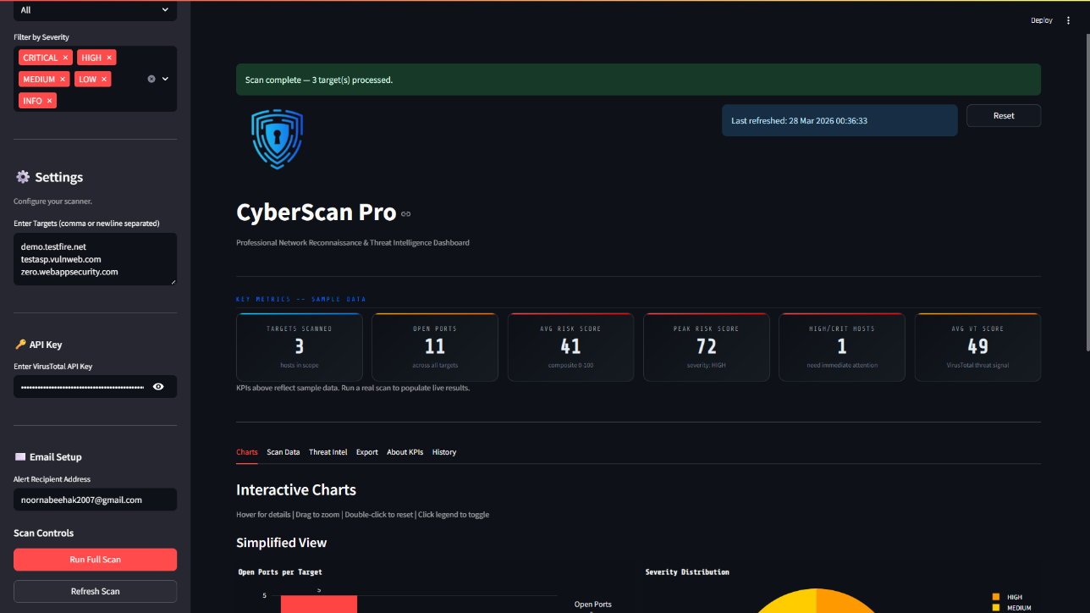
Scanning Complete (3 targets)

Scan Results (Naive User):
Interactive Charts:
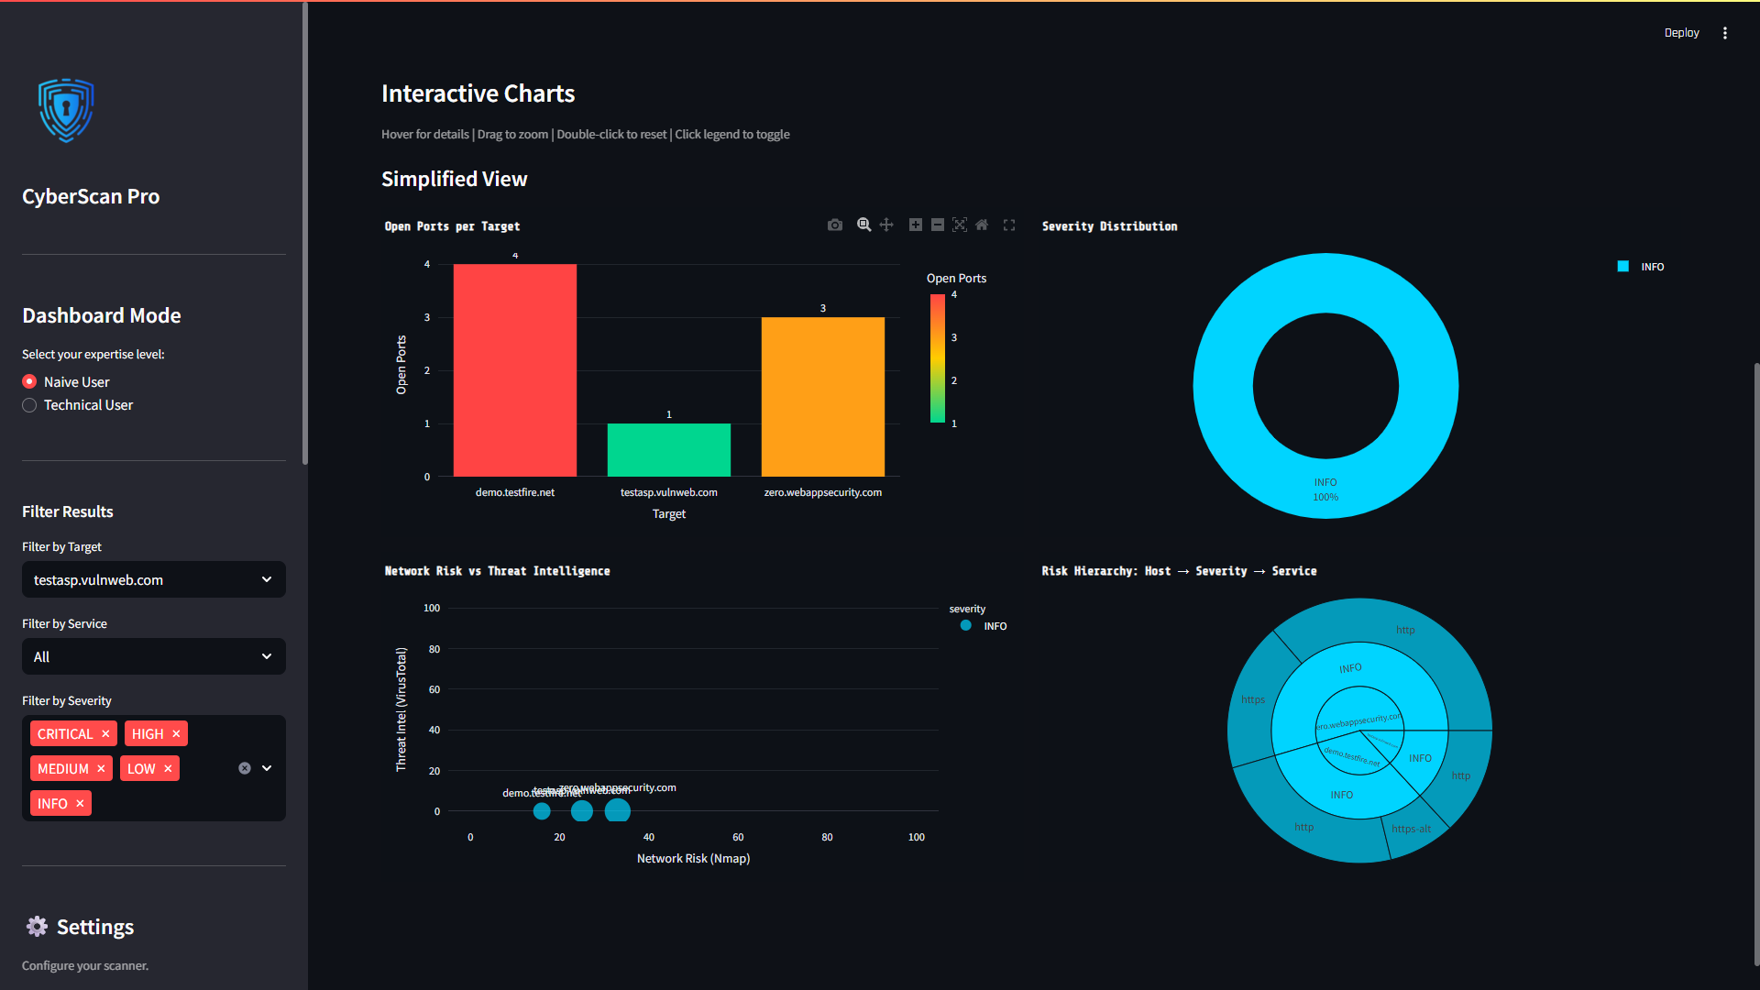
Visual Representation of Scan – 1
Scan Data:
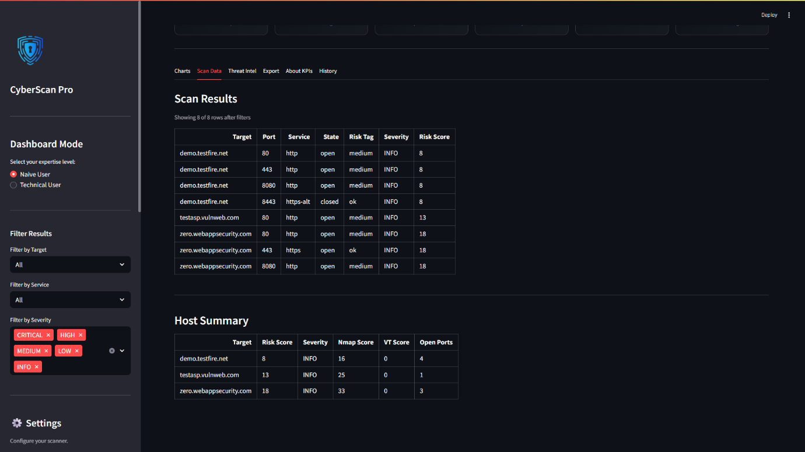
Scan Data of Scan – 1

Threat Intelligence + email module:
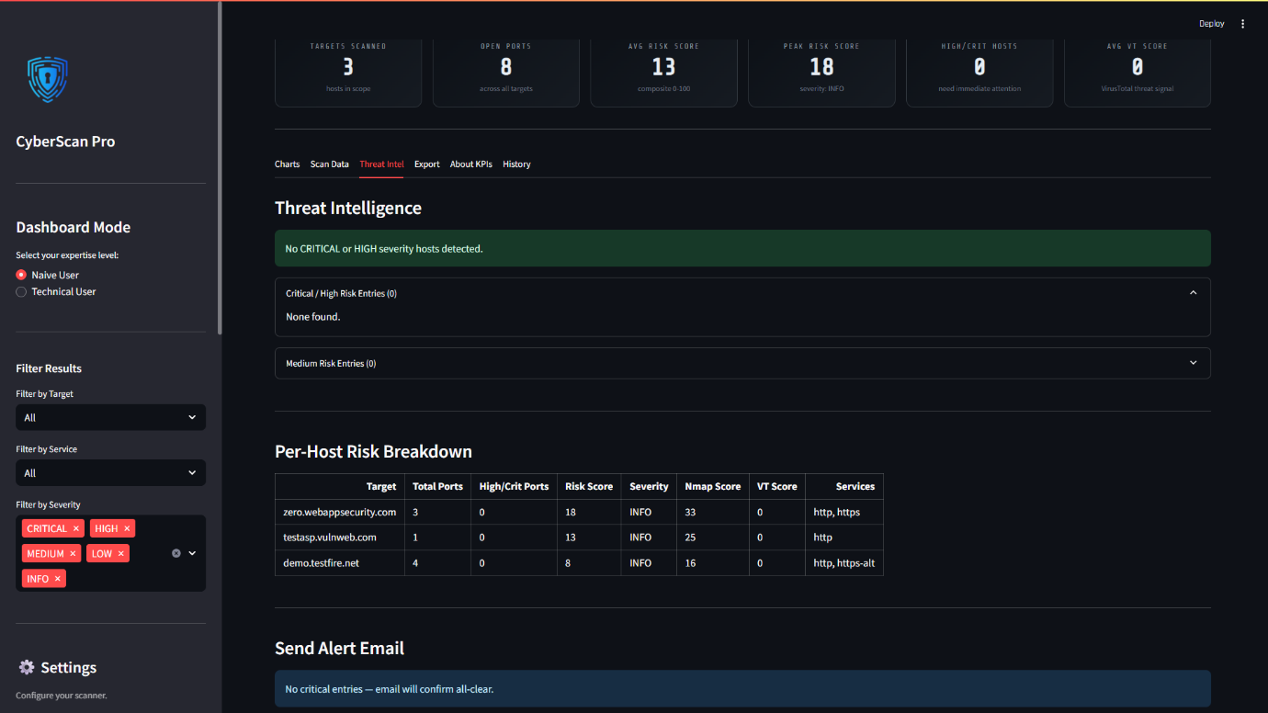
Threat Intelligence of Scan – 1
Exporting Results:
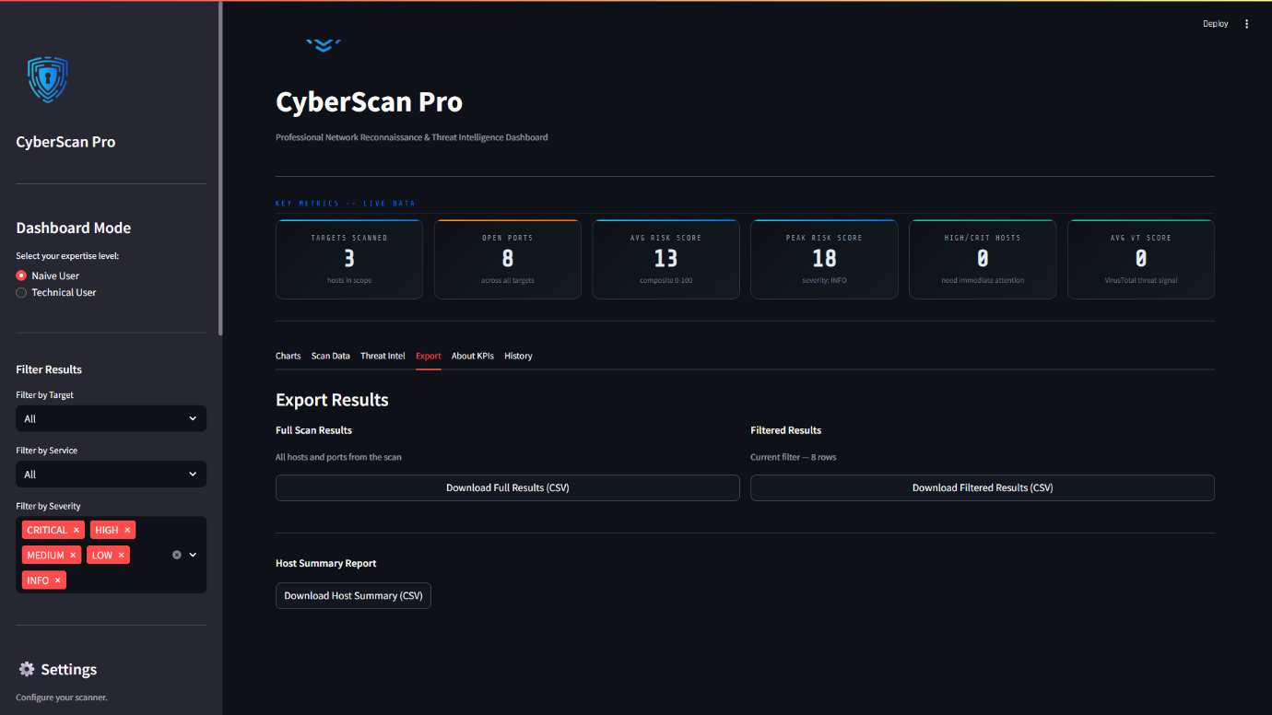
Exporting Results Scan – 1

KPIs:
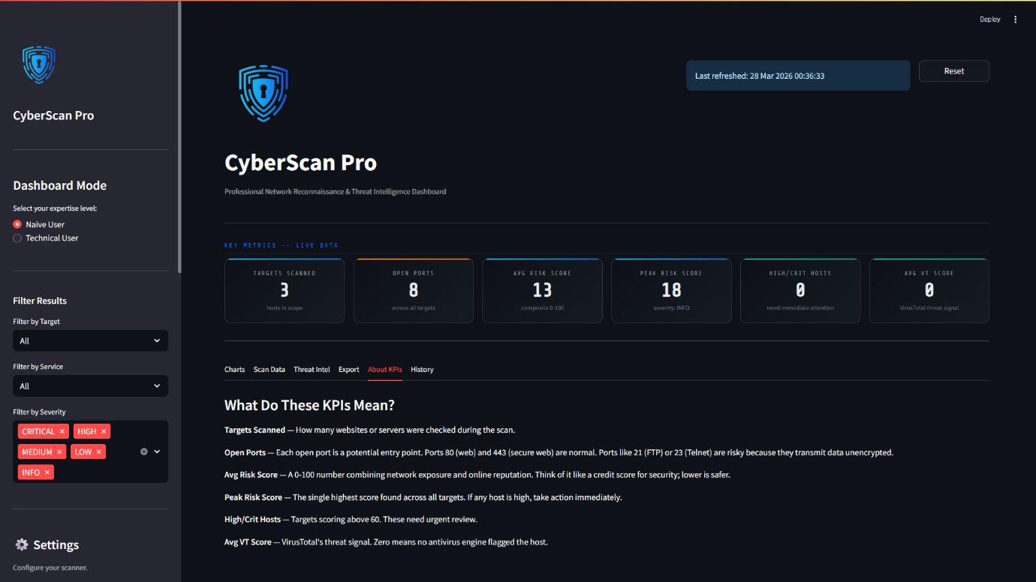
About KPIs Scan – 1

Scan Results (Technical User):
Interactive Charts:
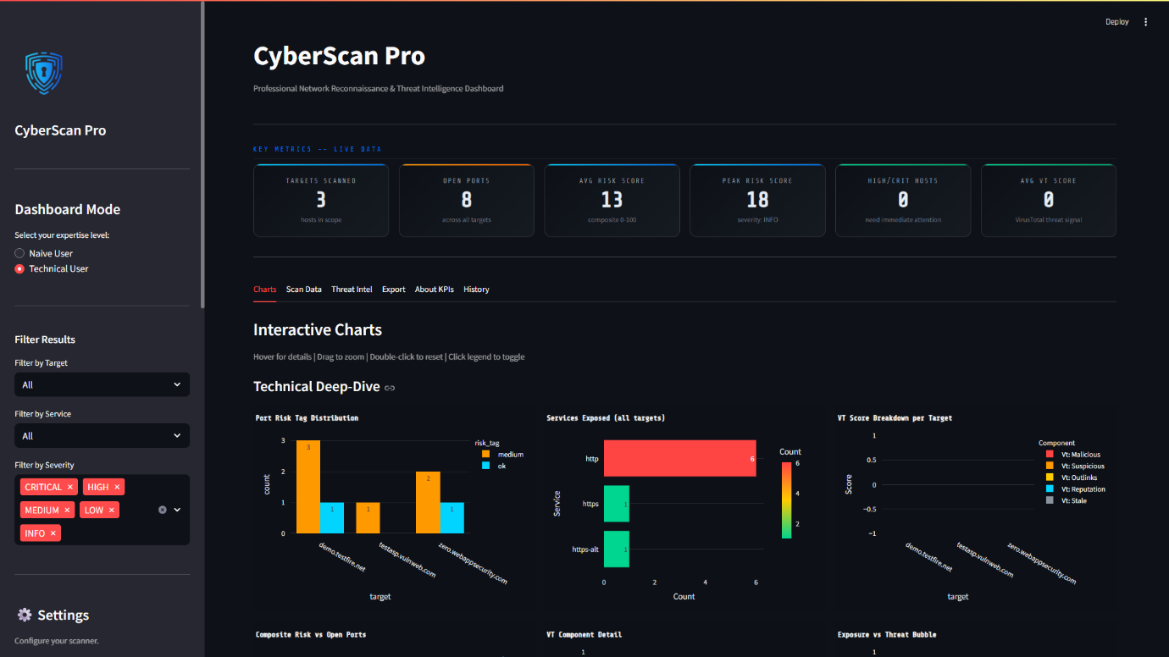
Visual Representation of Scan - 2
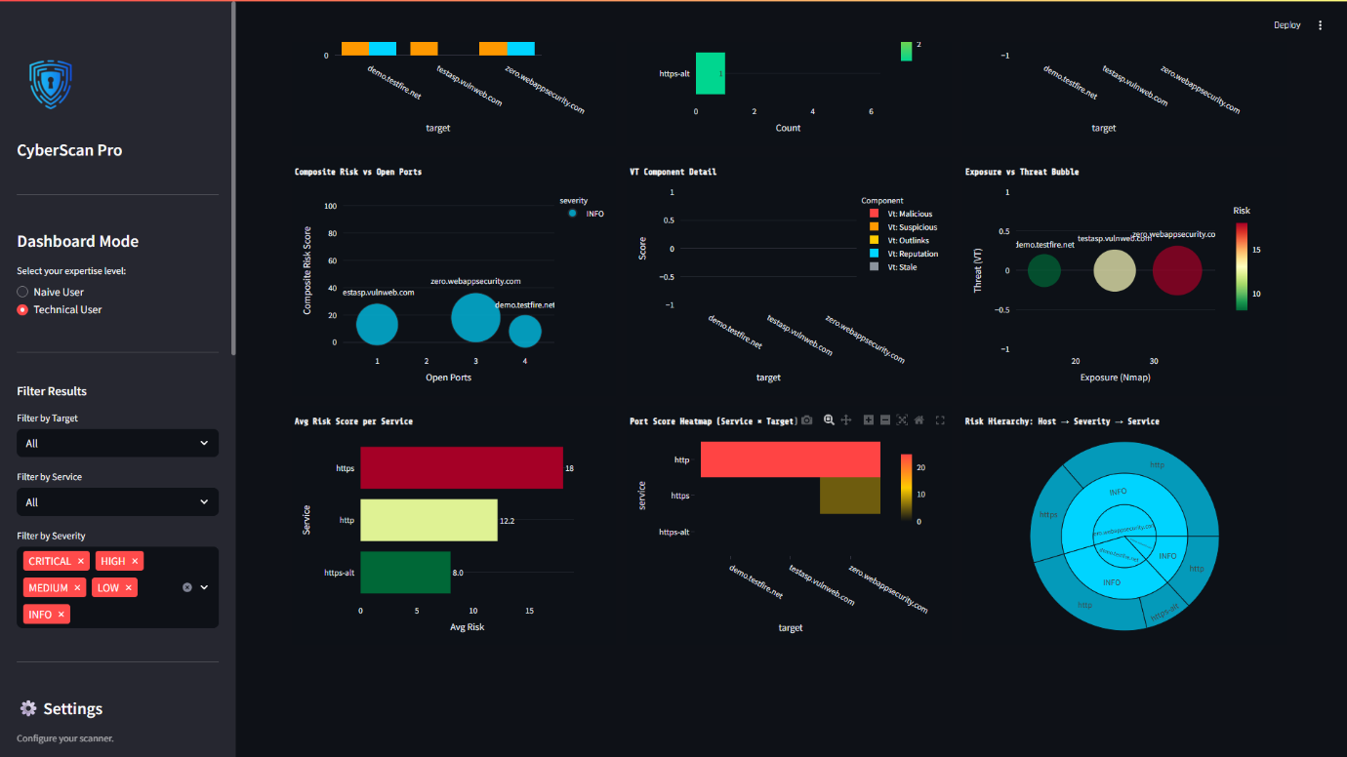
Visual Representation of Scan – 3

Scan Data:
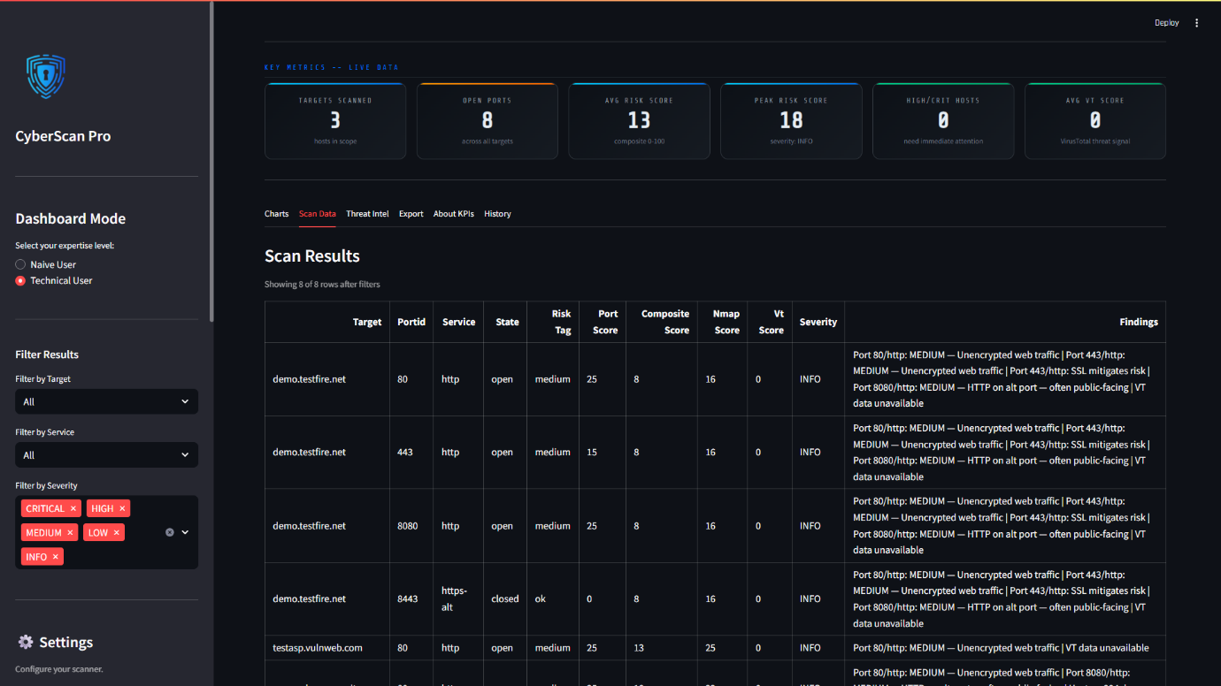
Scan Data of Scan – 2
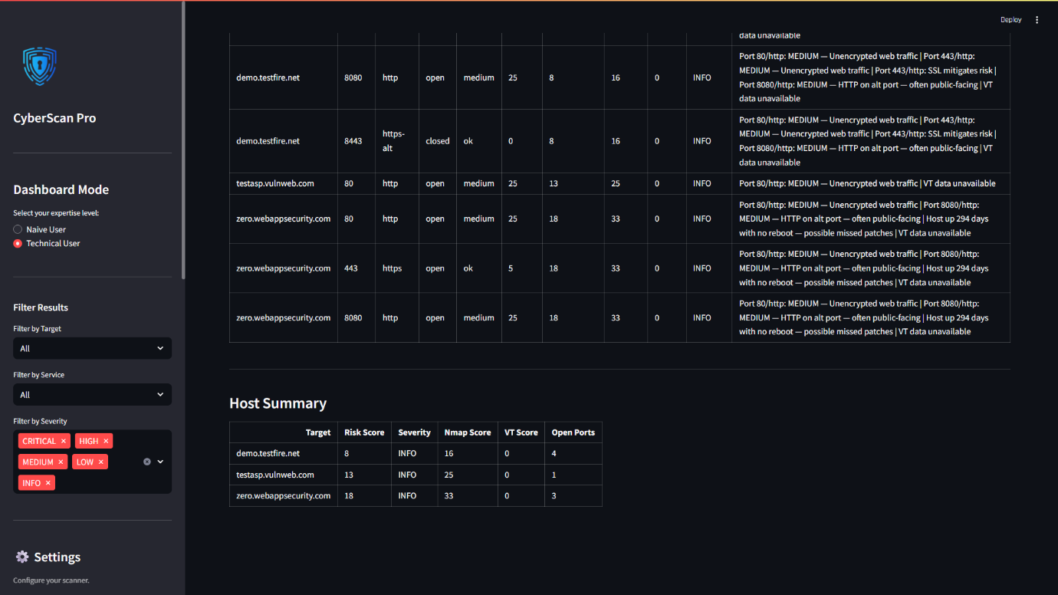
Scan Data of Scan – 3

Threat Intelligence + email module:
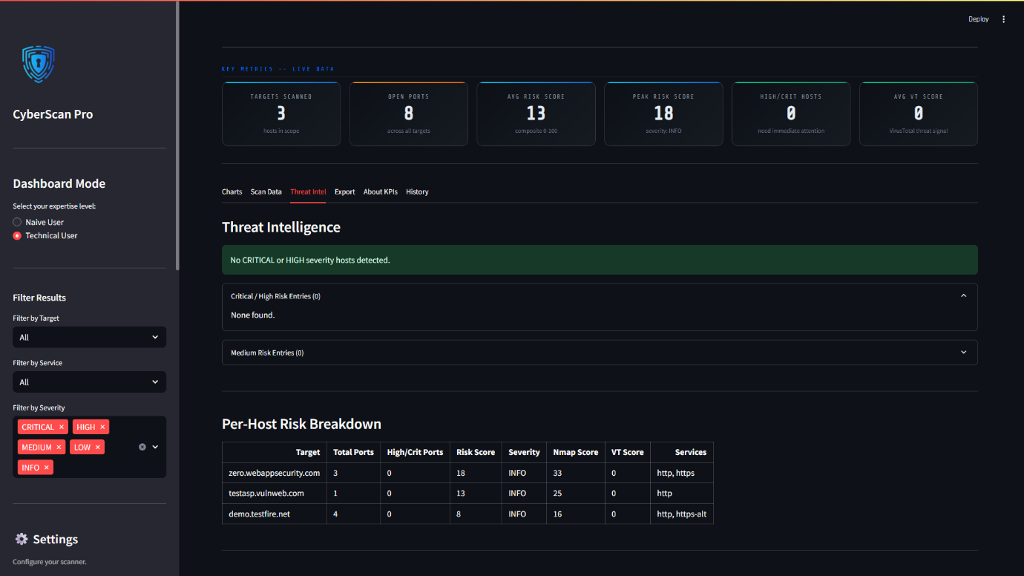
Threat Intelligence of Scan – 2
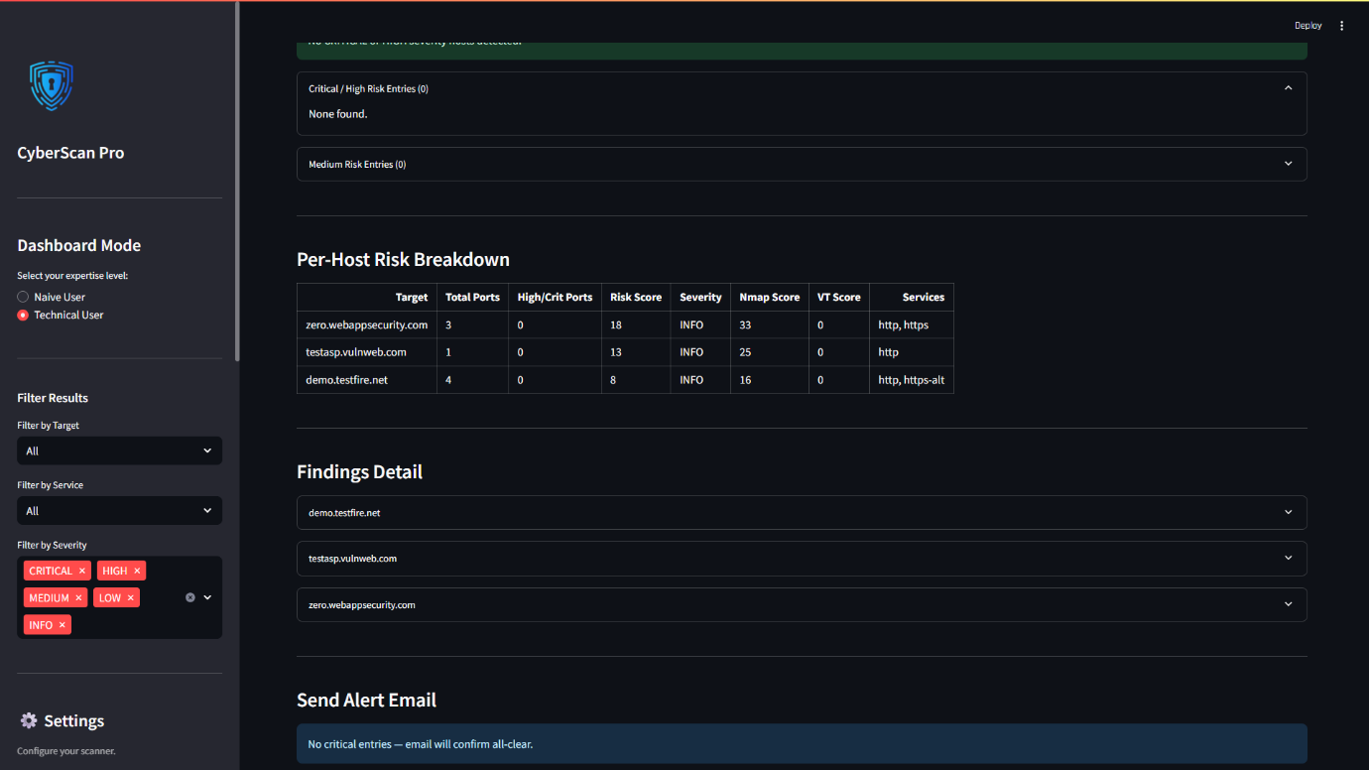
Threat Intelligence of Scan – 3

Exporting Results:
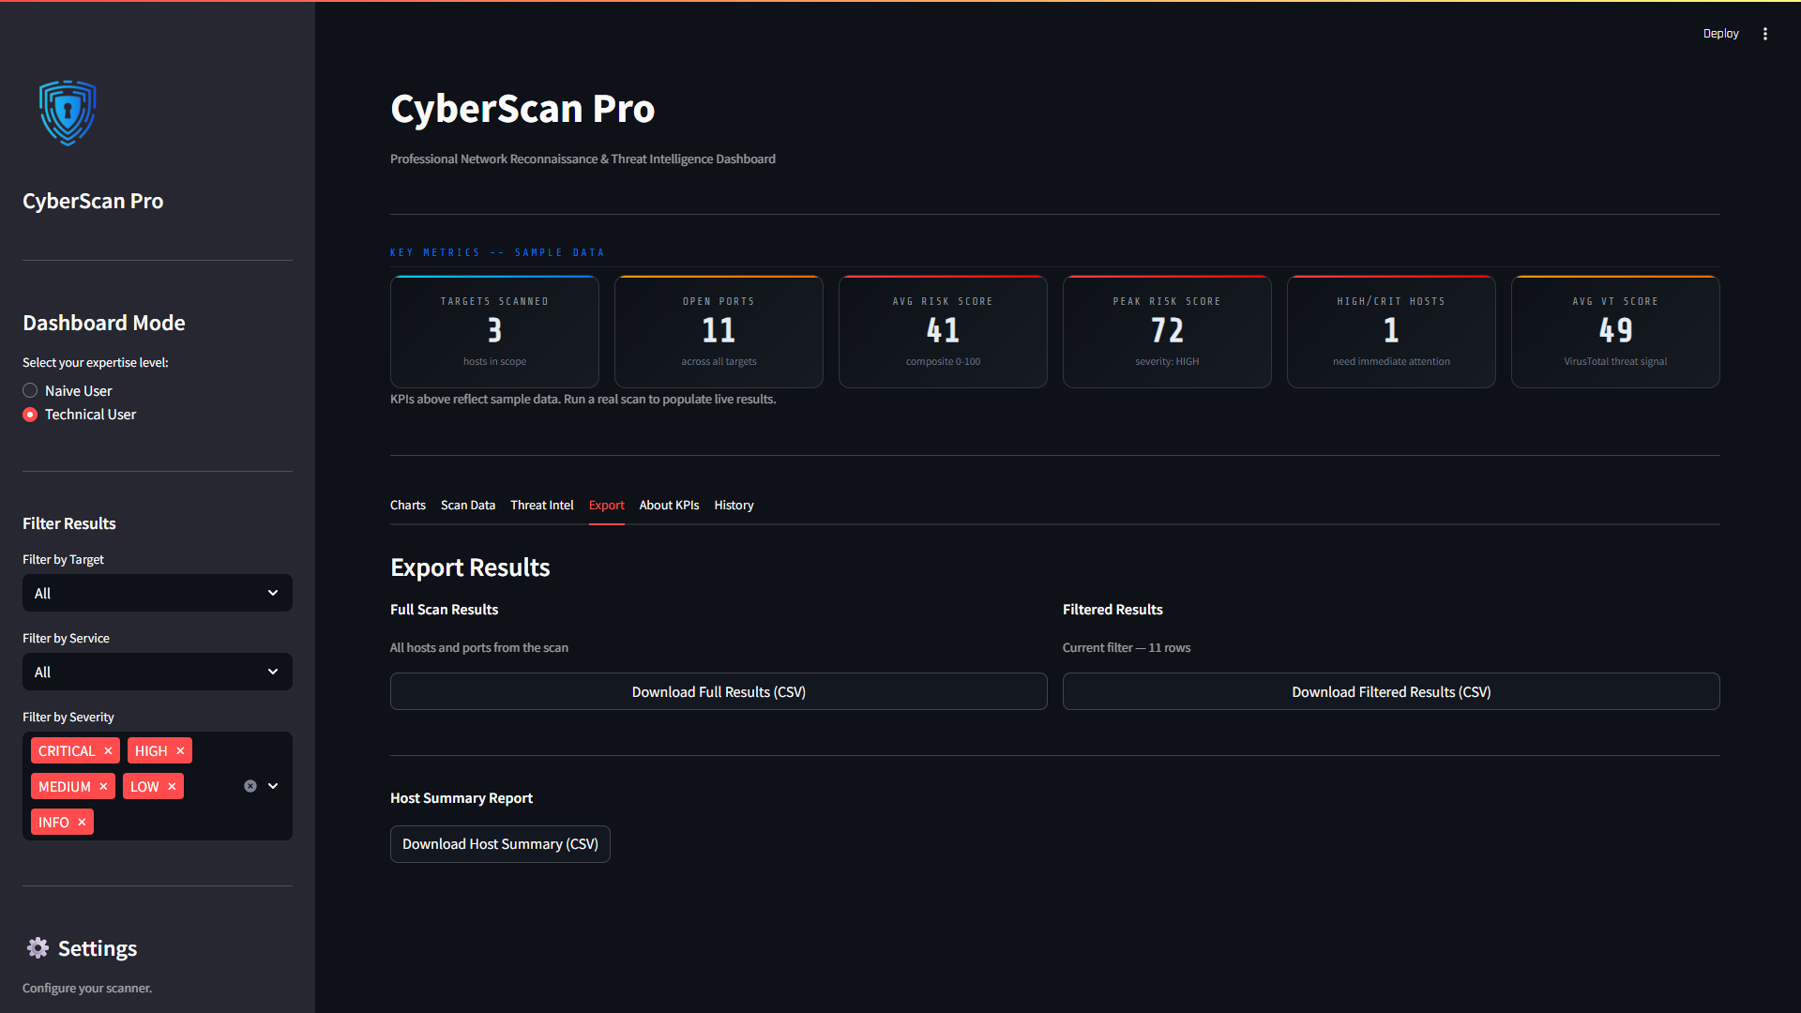
Exporting Results Scan – 2
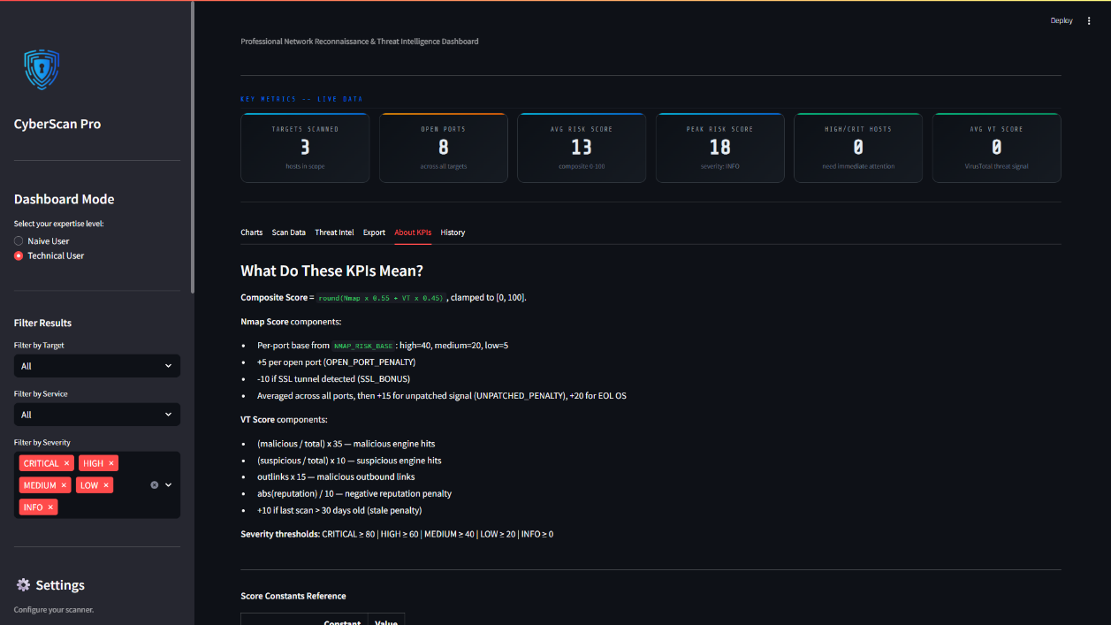
Exporting Results Scan – 3

KPIs:

About KPIs Scan – 2
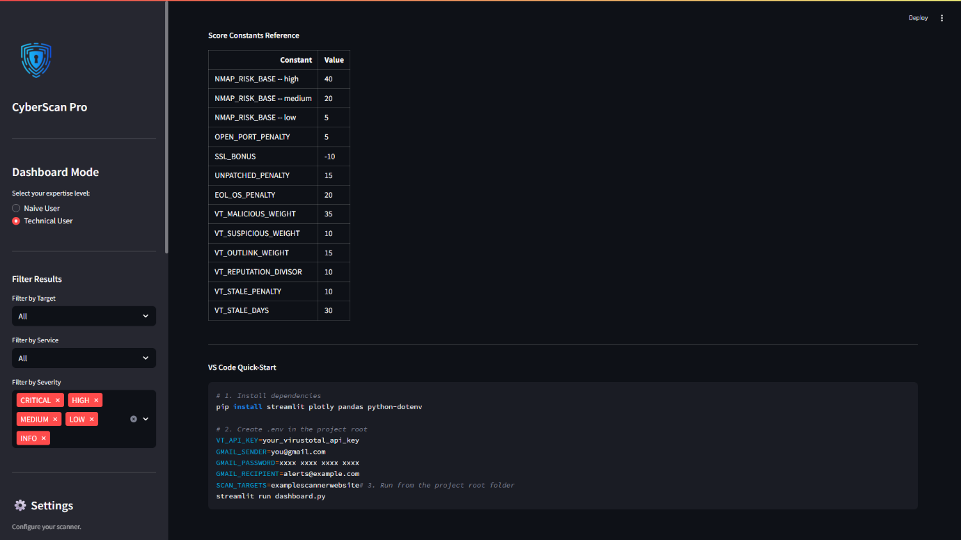
About KPIs Scan – 3

History Page (Naïve & Technical Users):
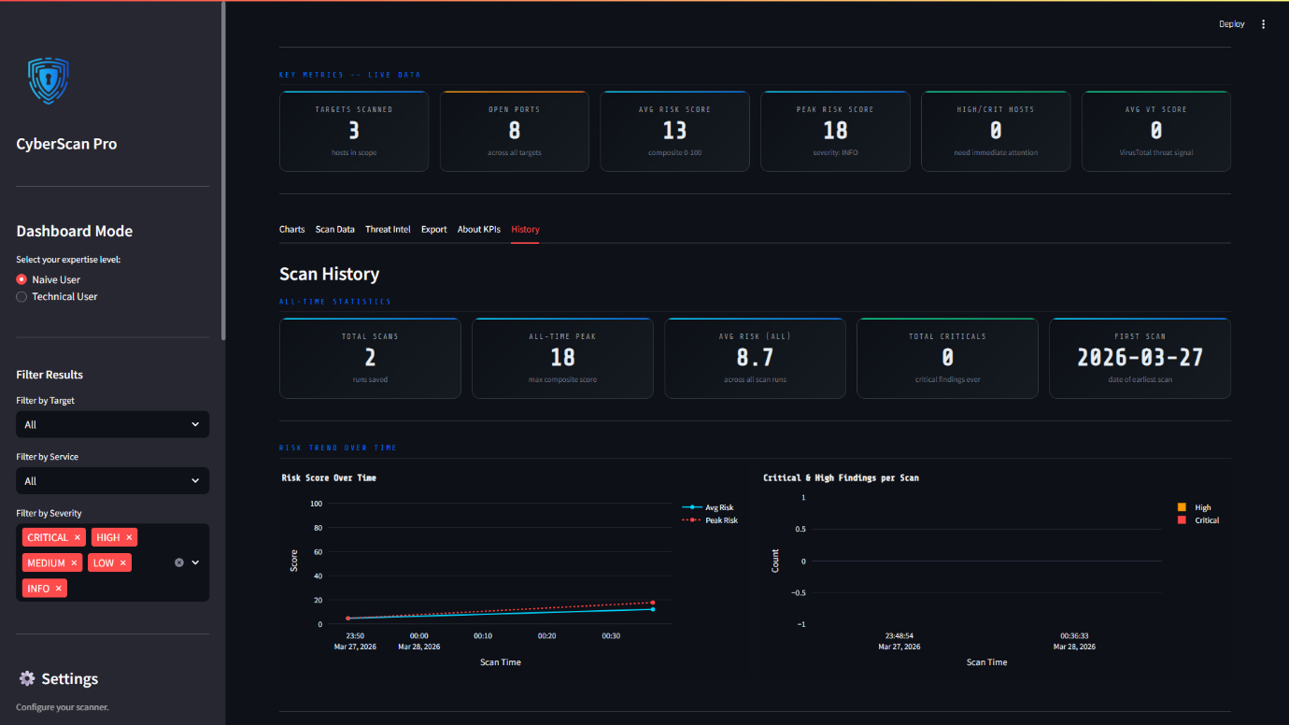
Comparing Scan results from previously stored Scan Data – 1
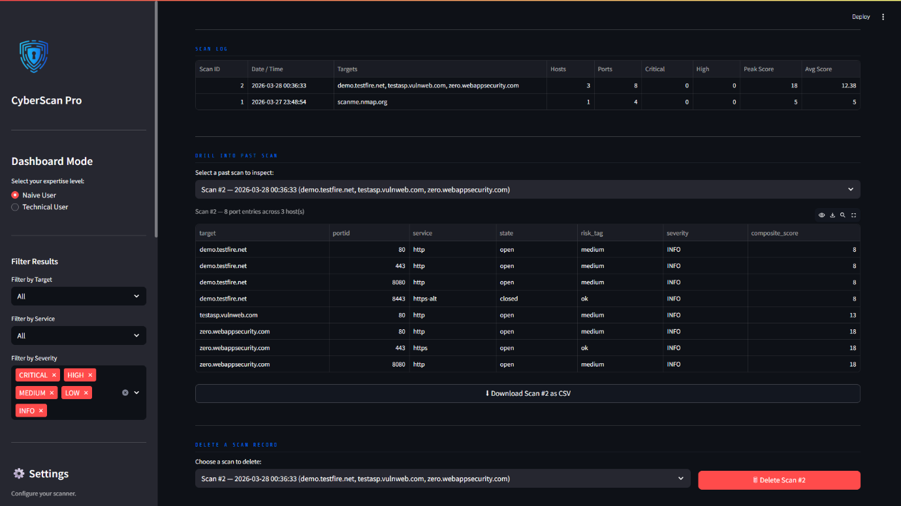Comparing Scan results from previously stored Scan Data – 2
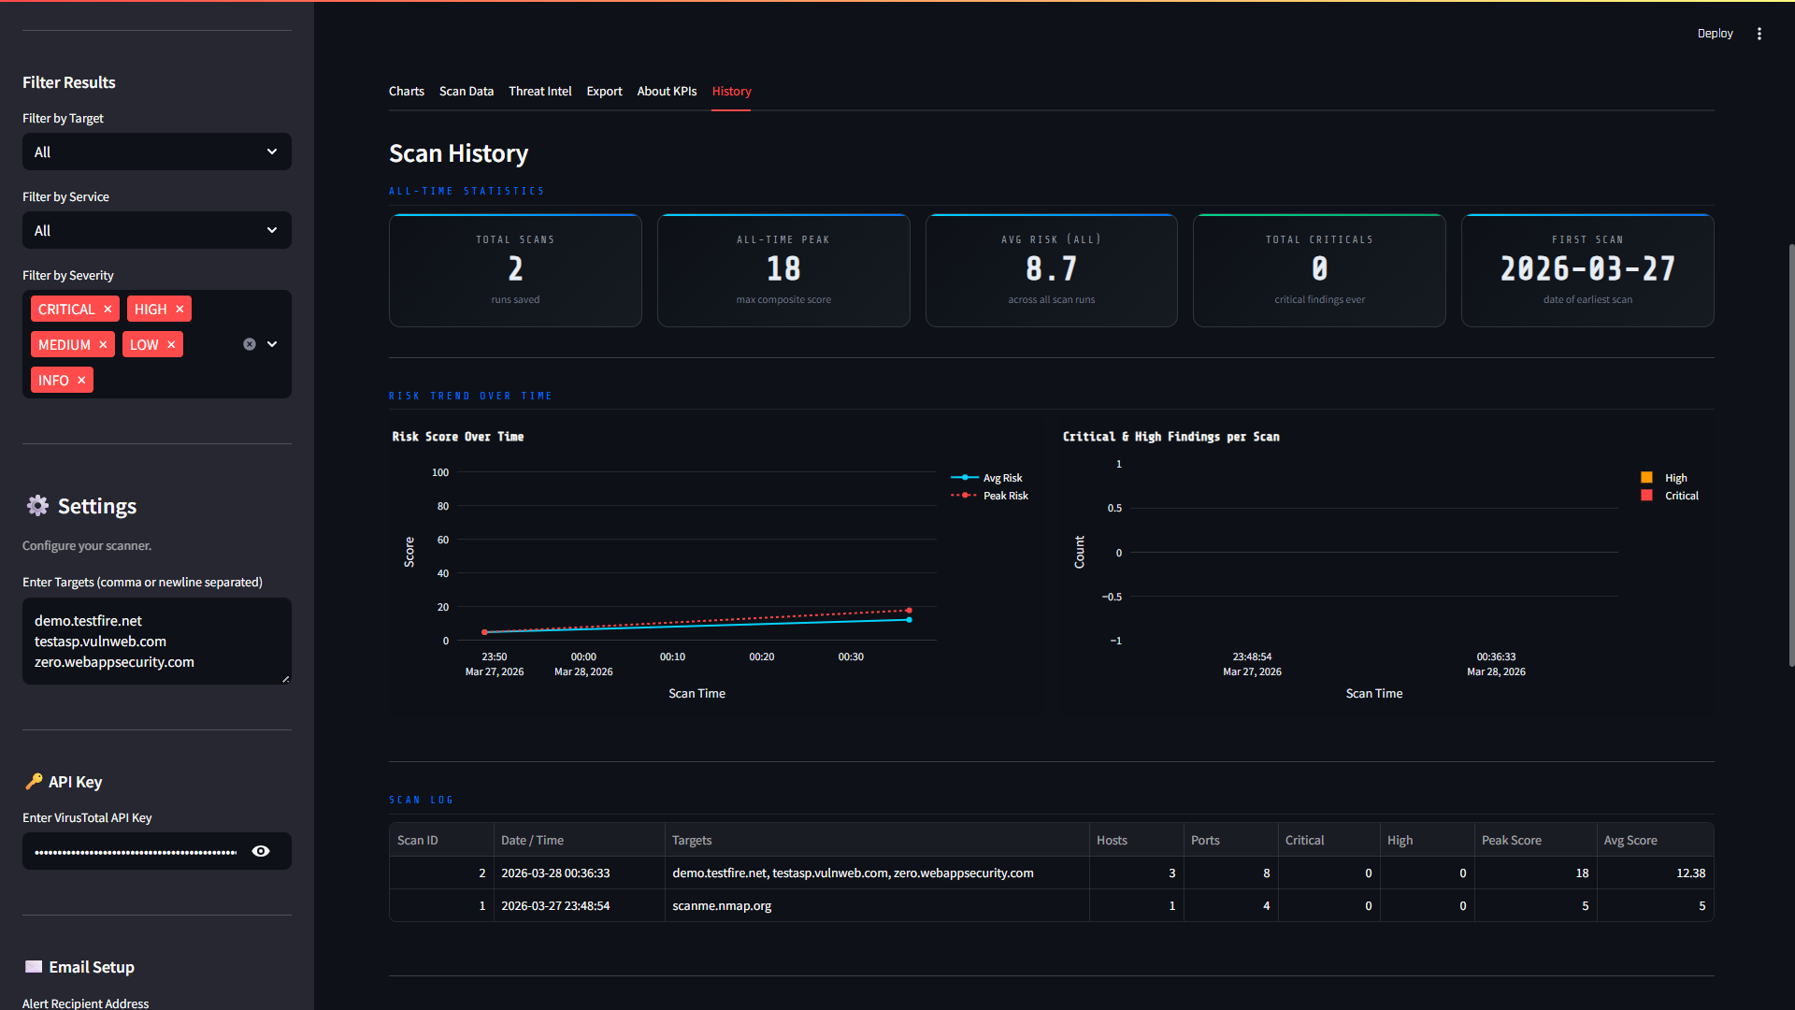
Comparing Scan results from previously stored Scan Data – 3
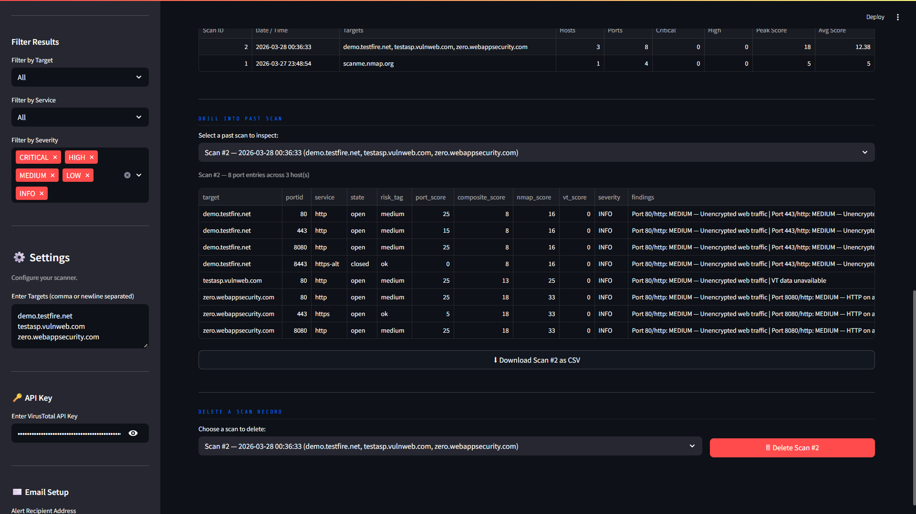
Comparing Scan results from previously stored Scan Data – 4

Filter Functionality (Naïve & Technical Users):
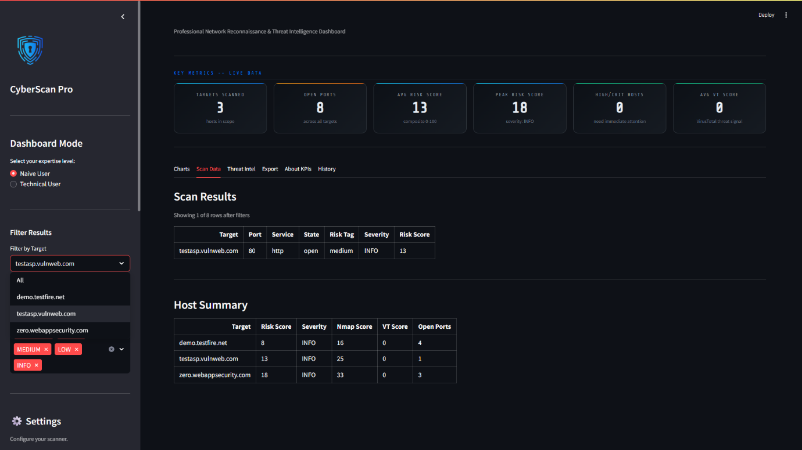
Filter applied on testasp.vulnweb.com under Scan Data - 1

